Lab 4

Task 1

Training U-Net using three-fold cross validation on the brain tumor MRI dataset.

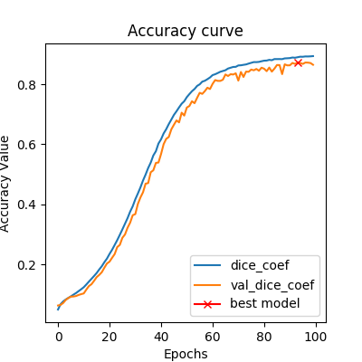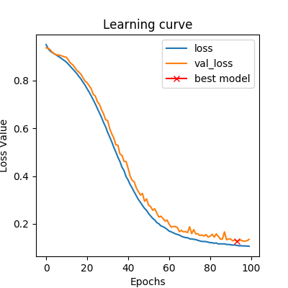

First Fold - Dice Coefficient First Fold - Loss Curve

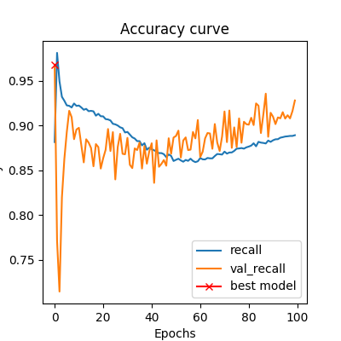 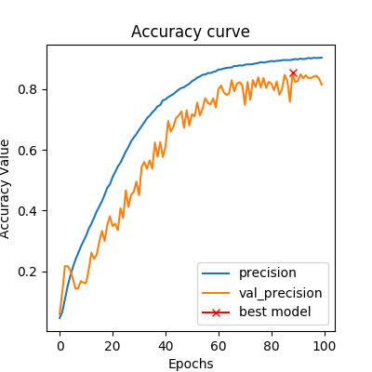

First Fold - Recall First Fold - Precision

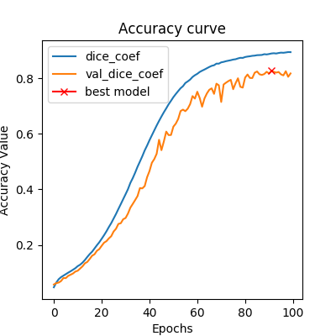 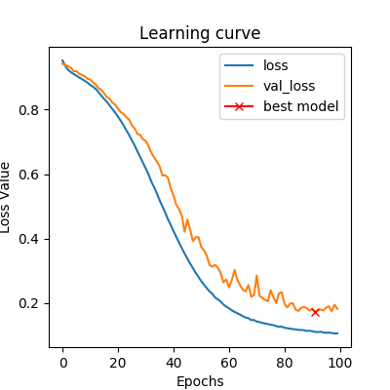

Second Fold – Dice Coefficient Second Fold – Loss Curve 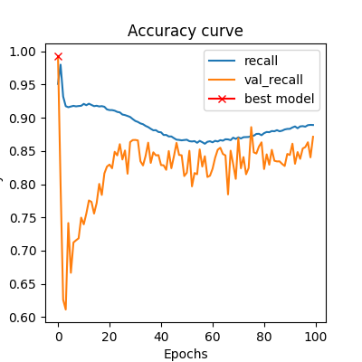 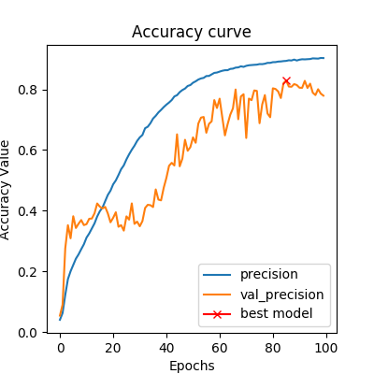

Second Fold – Recall Second Fold – Precision

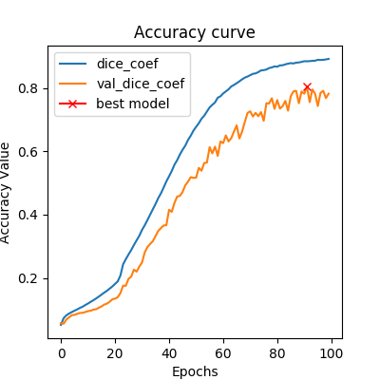 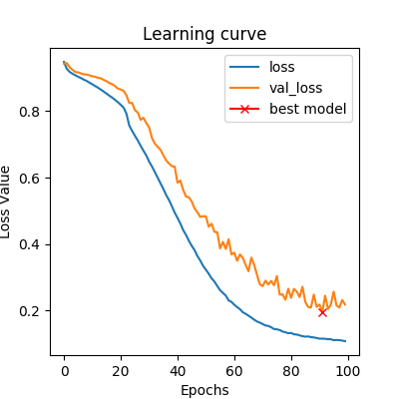

Third Fold – Dice Coefficient Third Fold – Loss Curve

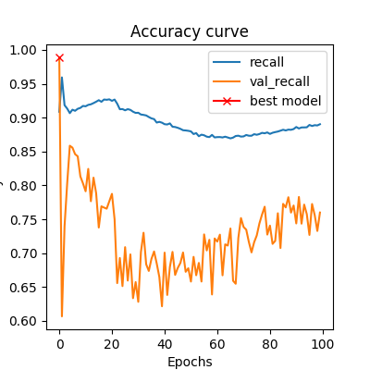 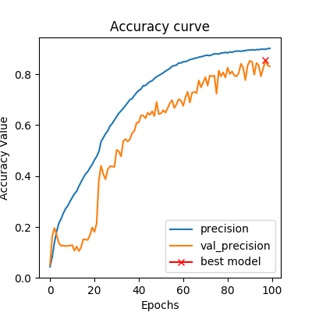

Third Fold – Recall Third Fold – Precision

As we can observe from the Accuracy curves (dice coefficient), the perfomance is consistant across all folds. While using cross validation, the final performance measure is an average of the model- perfomances acorss all the folds. It does not matter if the perfomance of some folds is different from the performace of other folds because the final perfomance result is an average of the results from all the folds.